Bilkent University

Department of Computer Engineering

Object Oriented Software Engineering Project

Project short-name: Mr.&Mrs. Pac-Man Ext.

Final Report

Ecem İlgün, Aziz Osman Kozhan, Başak Şevval Ekici, Talha Şeker

Supervisor: Bora Güngören

Nov 4, 2017

This report is submitted to the Department of Computer Engineering of Bilkent University in partial fulfillment of the requirements of the Object Oriented Software Engineering Project course CS319/2.

Contents

1. Changes in Implementation1

2. Current Status of the Project1

3. User’s Guide1

**3.1 System Requirements1**

**3.2 Installation2**

**3.3 Overview of the Game2**

**3.4 Game Entities Subsystem2**

3.4.1 Game Screenshots2

3.4.2 Controls6

3.4.1 Game Objects6

1) Changes in Implementation

In design report, we mainly divided into three layers the project. First, we decided to start to design user interface part of the project. However, as coding, we decided to regulate some class structures to improve implementation of the code. For example, we added PacLabel and PacButton classes not to repeat the same code again and again. We have added a GameMap class to hold non-moving objects. Hence, we aim to increase drawing efficiency. Moreover, we are planning to add new interface classes.

2) Current Status of the Project

The GUI part of the game is roughly completed. Right now, we did not focus on visual details of the frames. Instead of it, we handled simple design and flow of the pages. For game logic layer, we have written lots of code which is not completely integrated yet. For now, we completed pac-man object, pac-man can move and eat ghosts and food. However, ghosts cannot move yet and pac-man does not stop when it hits the wall. We think that it is better to start to data layer after completing GUI and game logic parts.

3) User’s Guide

Mr.&Mrs. Pac-Man Extended is a Java based arcade game. Therefore, to launch the game, user must have java runtime environment (jre) which can be easily found. The game can be launched in common operating systems.

3.1 System Requirements

Recommended System Requirements:

• Windows 10, Linux, MacOS

• Intel core 2 duo 1.6 GHz CPU or higher

• 256 MB of RAM or higher.

• Screen Resolution: 800x600

3.2 Installation

Compiling and running the code with an IDE is an only way to launch our game at this time. However, at the end the game will be able to be launched by clicking .jar extension of the game.

3.3 Overview of the Game

When game starts, an animation starts and then main menu screen appears. If player clicks question mark, help screen will appear and player can get information about items. When player starts the game, s/he can manage pac-man icon and pac-man can eat ghosts and food. These ghosts are placed randomly on the map. We did not complete collision logic yet. If player selects two players option, there will be two icons on the screen and they can be moved by players.

3.4 Game Entities Subsystem

3.4.1 Game Screenshots

Animation Screen: The screen which appears when the game launches.

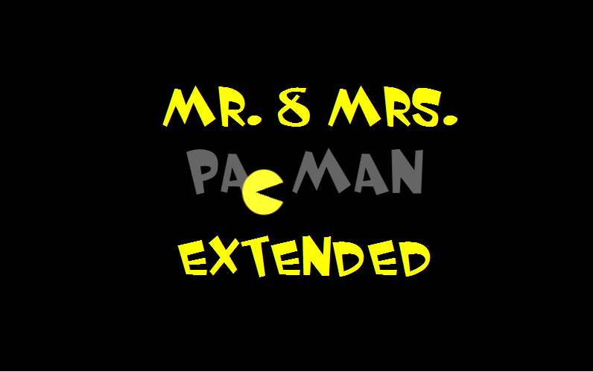

Main Menu Screen: After animation this main menu screen appears.

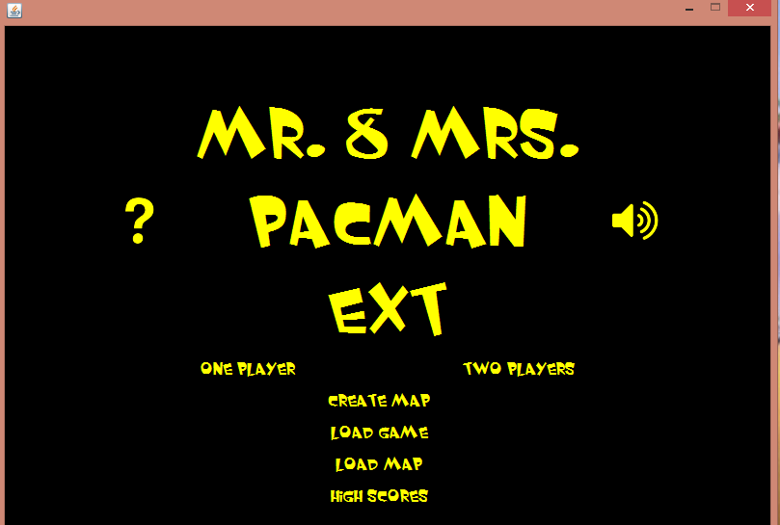

Pause Menu: When player presses ‘P’ during the game, pause menu appears.

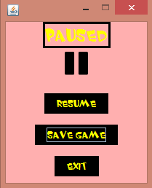

Help Panel: If player clicks question mark on the main menu, help panel will appear.

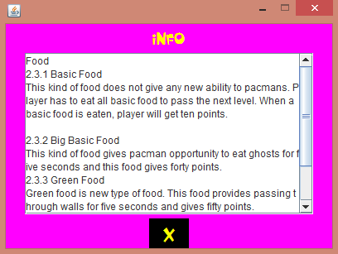

Shield Menu: This panel will appear after first or second levels are completed.

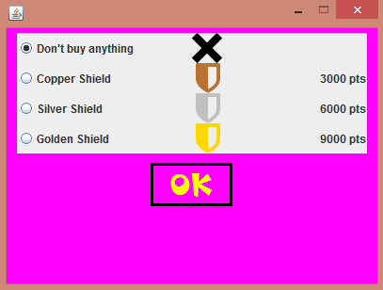

Saved Games Panel: This menu shows list of the saved games. Player can play one of them.

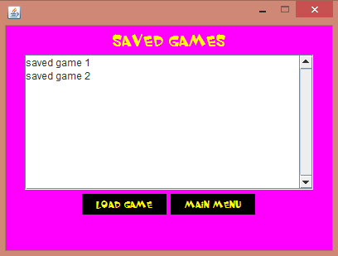

High Score List: This list shows saved high scores.

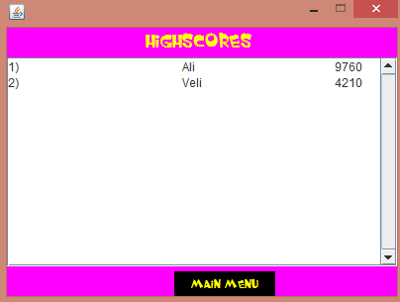

Game Over: This page is end of the game and provides going back to main menu.

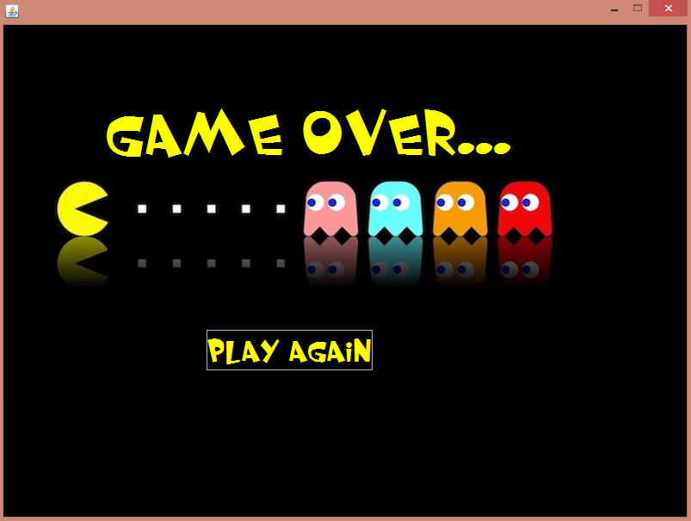

3.4.2 Controls

-Mrs. Pac-Man: W, A, S, D

W: up, A: left, S: down, D: east

-Mr. Pac-Man: Arrow keys

P: Pause

3.4.3 Game Objects

* Mr. Pac-man: One of the main objects of the game. First player controls Mr. Pac-man with arrow keys.
* Mrs. Pac-man: Other main object of the game. Second player controls Mrs. Pac-man with W, A, S, D.
* Ghosts: Enemies of the pac-mans and they try to catch pac-man. They cannot move yet.
* Food: Food items are eatable right now; however, we did not implement score logic yet.